**Spring 2024: CS5720**

**Neural Networks and Deep Learning - ICP-2**

**Name: Bala Rishik Marneni**

**Student id: 700746746**

**Video Link:** [**https://drive.google.com/file/d/14FKsuliqUSz_a21s0skMIGYGdU482Uqc/view?usp=drive_link**](https://drive.google.com/file/d/14FKsuliqUSz_a21s0skMIGYGdU482Uqc/view?usp=drive_link)

**Github Link:** [**https://github.com/BalaRishik001/Neural-Networks-and-Deep-Learning-Assignments**](https://github.com/BalaRishik001/Neural-Networks-and-Deep-Learning-Assignments)

1. Write a program that takes two strings from the user: first_name, last_name. Pass these variables to fullname function that should return the (full name).
   * For example:
     + First_name = “your first name”, last_name = “your last name”
     + Full_name = “your full name” o Write function named “string_alternative” that returns every other char in the full_name string. Str = “**G**o**o**d e**v**e**n**i**n**g”

Output: Go vnn

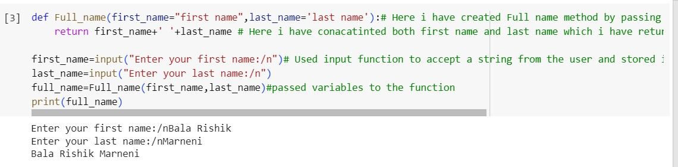

Write function named “string_alternative” that returns every other char in the full_name string. Str = “Good evening” Output: Go vnn

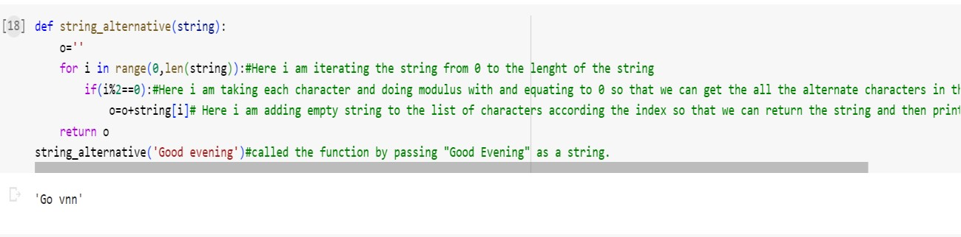

2. Write a python program to find the wordcount in a file (input.txt) for each line and then print the output. o Finally store the output in output.txt file.

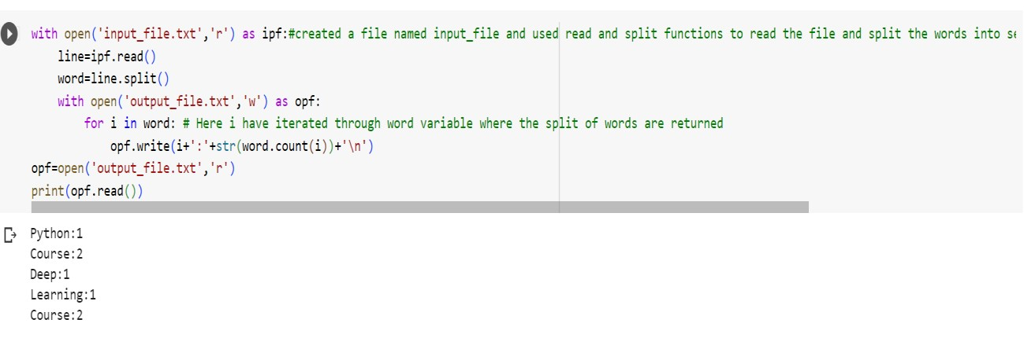

3. Write a program, which reads heights (inches.) of customers into a list and convert these heights to centimeters in a separate list using:

1. Nested Interactive loop.
2. [List comprehensions](https://www.w3schools.com/python/python_lists_comprehension.asp)

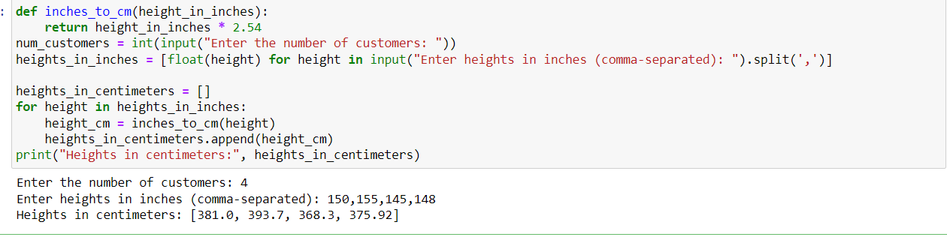

**Thank You**